DAT 530 uCertify Lab Activity Worksheet

Module Labs
- 2.2.2 Creating a Static Line Plot
- 2.2.4 Creating a Static Scatterplot
- 2.2.5 Creating a Static Contour Plot
- 2.2.6 Creating a Static Heat Map
- 2.3.1 Creating a Static Box

Lab Screenshots
- 2.2.2 Creating a Static Line Plot
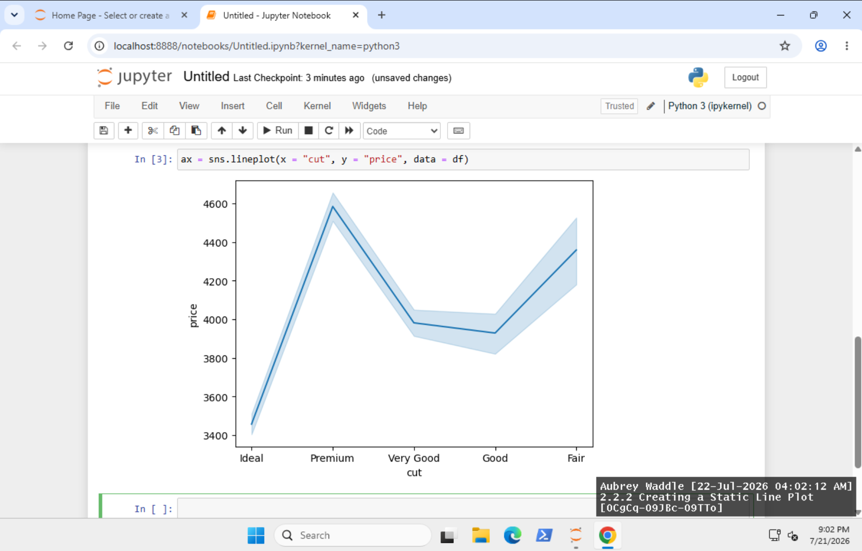
- 2.2.4 Creating a Static Scatterplot
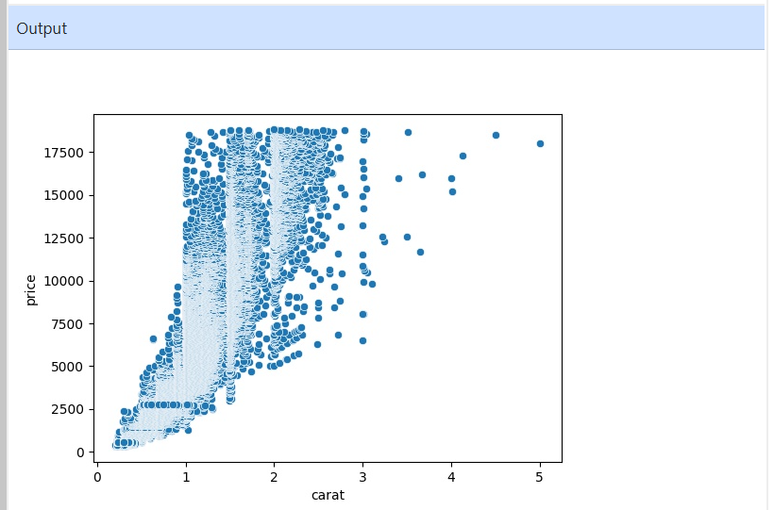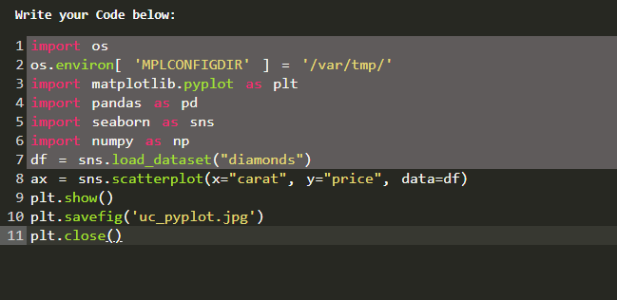
- 2.2.5 Creating a Static Contour Plot
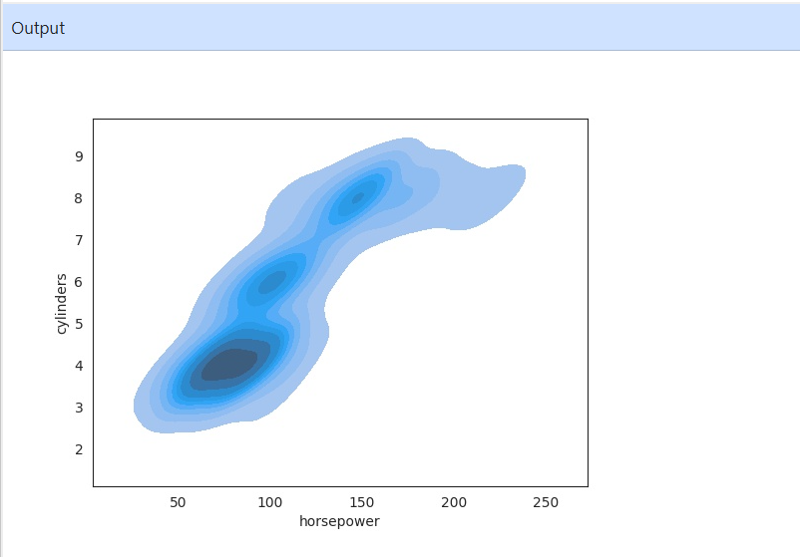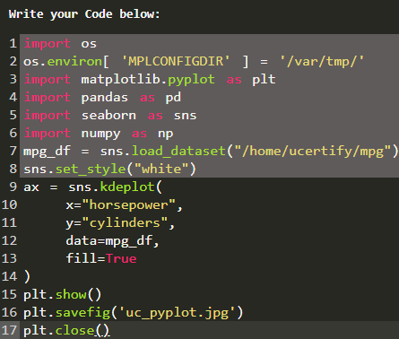
- 2.2.6 Creating a Static Heat Map
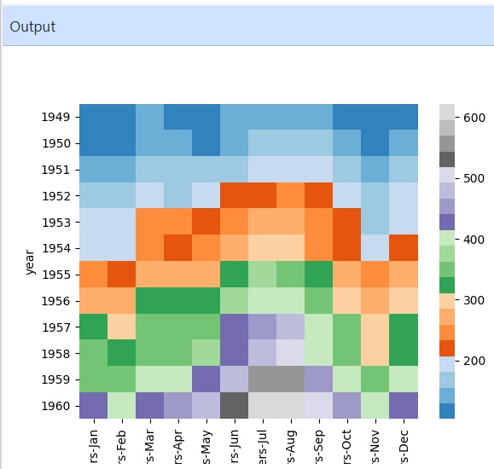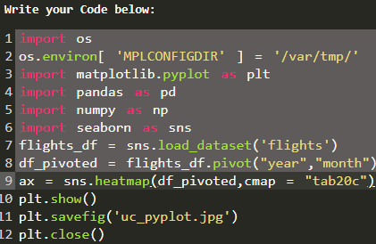

- 2.3.1 Creating a Static Box
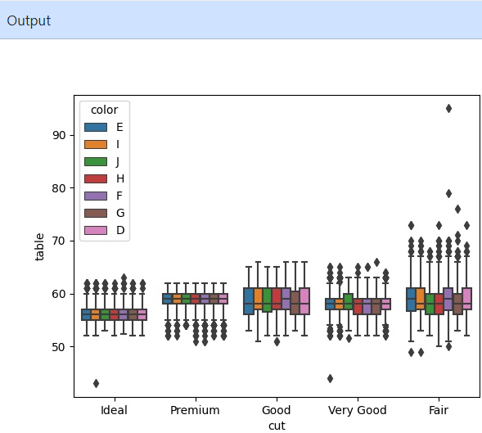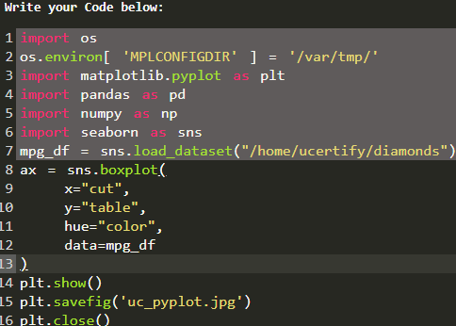

Lab Reflection

- 2.2.2 Creating a Static Line Plot
For this lab I built out a static line plot using the sns.lineplot(x="cut", y="price", data=df) function. The visualization shows the average price for each diamond cut and the confidence interval around it. A line plot is one of the most powerful ways to show trends or changes over an ordered series of numbers. They are of enormous value to analysts and decision-makers whose job is to look for trends rather than fine detail.

- 2.2.4 Creating a Static Scatterplot
I made some scatter plots with the code: sns.scatterplot(x="carat", y="price", data=df). The scatter plot showed every single observation in the data set, and was thus a much better tool for presenting clusters, outliers and relationships than the line plot. Such a depiction is very helpful to those who perform analysis and research on correlations between numerical variables.

- 2.2.5 Creating a Static Contour Plot
Here, I plotted a filled contour plot using sns.kdeplot(x="horsepower", y="cylinders", data=mpg_df, fill=True) We grouped regions with a high number of observations in order to simplify the data presentation and not to overload the viewer with individual numbers. When working with vast volumes of data, contour plots can be used to find patterns and distributions. “They help to simplify a large amount of data compared to scatter plots.

- 2.2.6 Creating a Static Heat Map
I tried sns.heatmap(df_pivoted, cmap="tab20c"). The cmap heatmap from the lab was a useful way to visualize the seasonal trends in the number of passengers, separated by year and month. The intensity of the colors represented the number of passengers. Heatmaps can summarize massive amounts of data in an easily understood manner and will likely be more useful to business professionals and decision makers interested in high-level trends in the data than previous representations based on individual observations or correlations.

- 2.3.1 Creating a Static Box
For this experiment I created a grouped box plot using sns.boxplot(x="cut", y="table", hue="color", data=mpg_df) This visualization summarized the distribution of the table data for different diamond cuts . Color coding was used to separate each group . Analysts and researchers choose the box plot to compare distributions for different categories, because it gives a better picture of medians, variability and outliers than the other representations.

